Use this reference to change the catalog year (effective date).

Catalog Year is reading off of Effective Date of Academic Requirements in Workday.

Step 1: To see the Effective Date of Academic Requirements in Workday, go to the Academic Progress tab. Scroll to the major and you can see the academics requirements.’

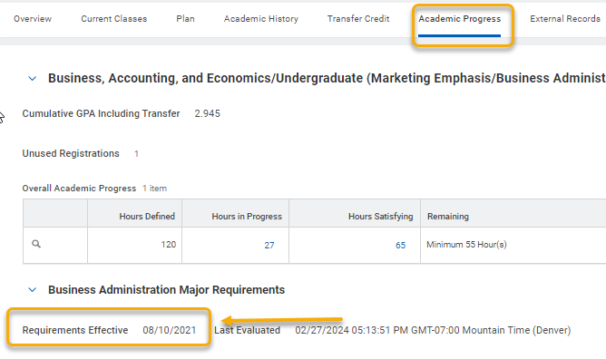

Step 2: To update this, go to Actions, Advising, and select Override Academic Requirements

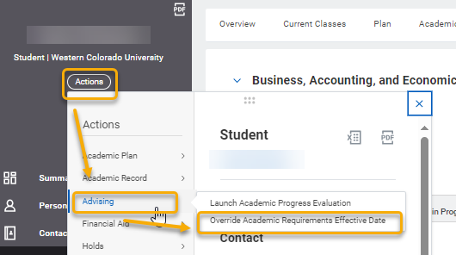

Step 3: The student’s name will appear. Click OK.

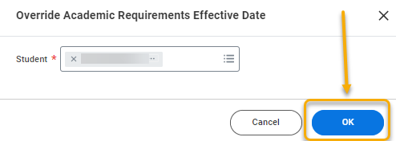

Step 4: Select the program of study you want to change the effective date.

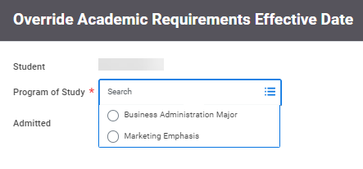

Step 5: Enter in the effective date (catalog year) it should be and click OK. Before doing this, to see the options available for the effective date (as not all are built in Workday). To see the options go in a new tab to: View Academic Requirements. Select Program of Study/Program Focus, then select the Program of Study or Program Focus (as some academic requirements are on the focus), and click Existing to see the available options for effective dates.
